Week 1 - S1 - Practice Problem Solution

Ramesh Harisabapathi Chettiar

RA2411030010263

Date of Submission:17/08/2025

🛠 **PRACTICE PROBLEM 1:**

**String Creation and Manipulation**

**Task**: Create a program that demonstrates different ways to create strings and basic manipulation.

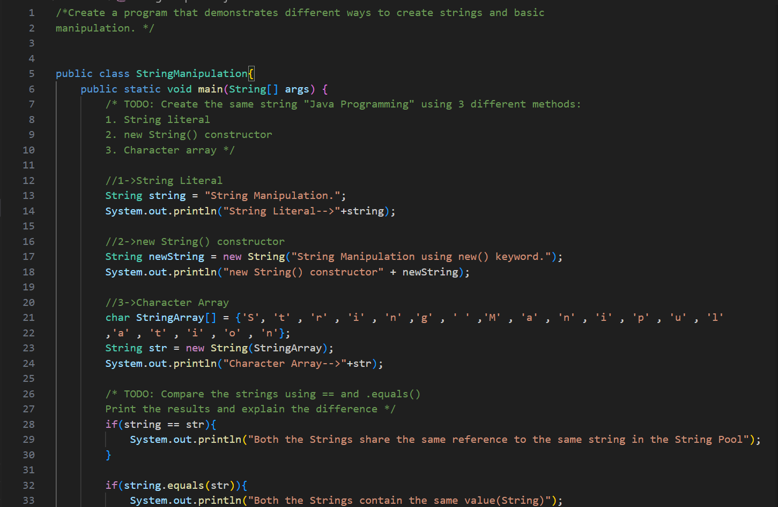

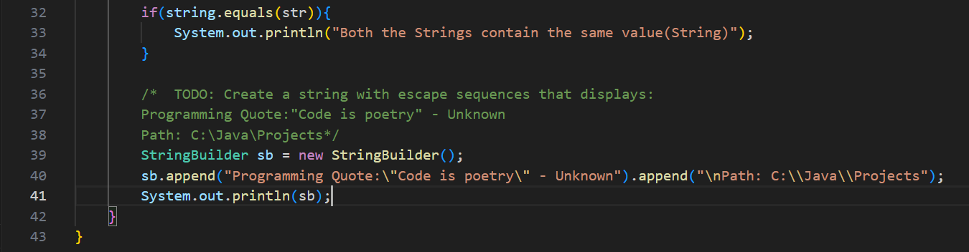

🛠 **PRACTICE PROBLEM 2: String Input and Processing**

**Task**: Create a program that takes user input and processes it using various string methods.

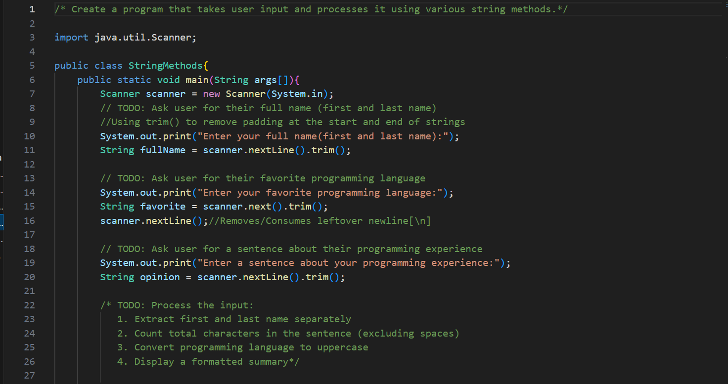

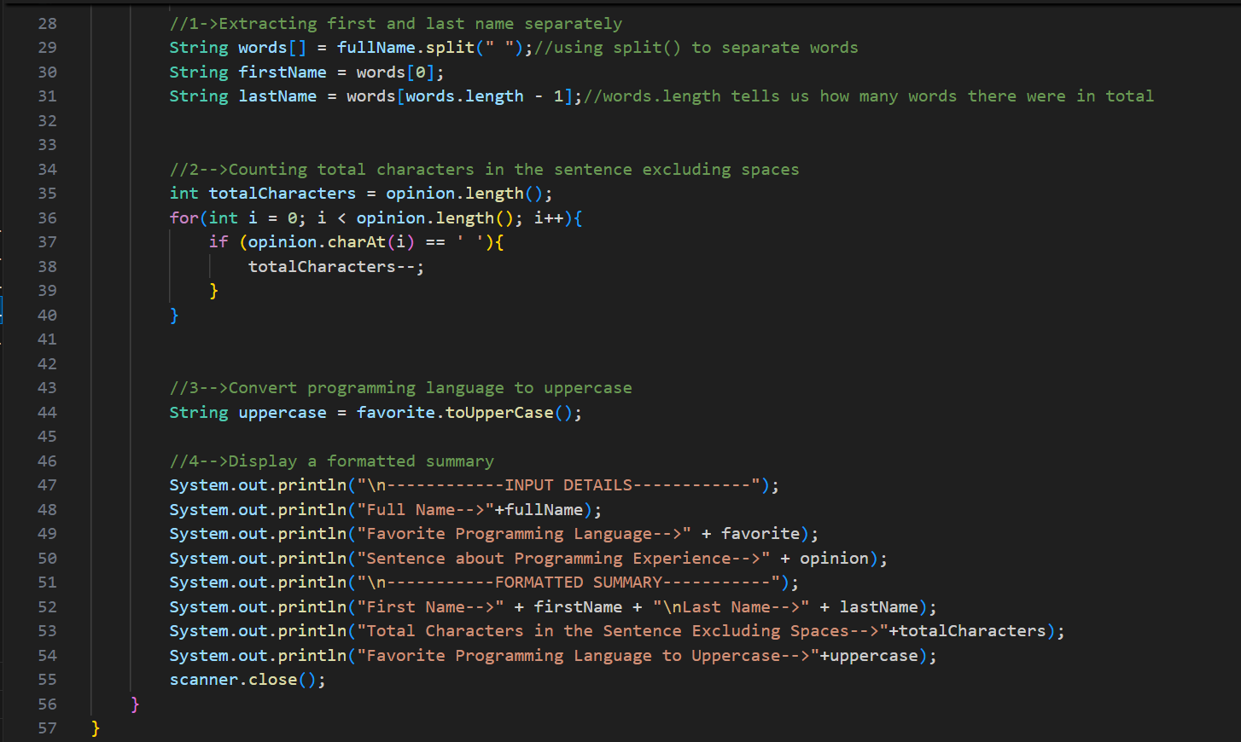

🛠 **PRACTICE PROBLEM 3:**

**String Arrays and Methods**

**Task**: Create a program that manages a list of student names using string arrays and methods.

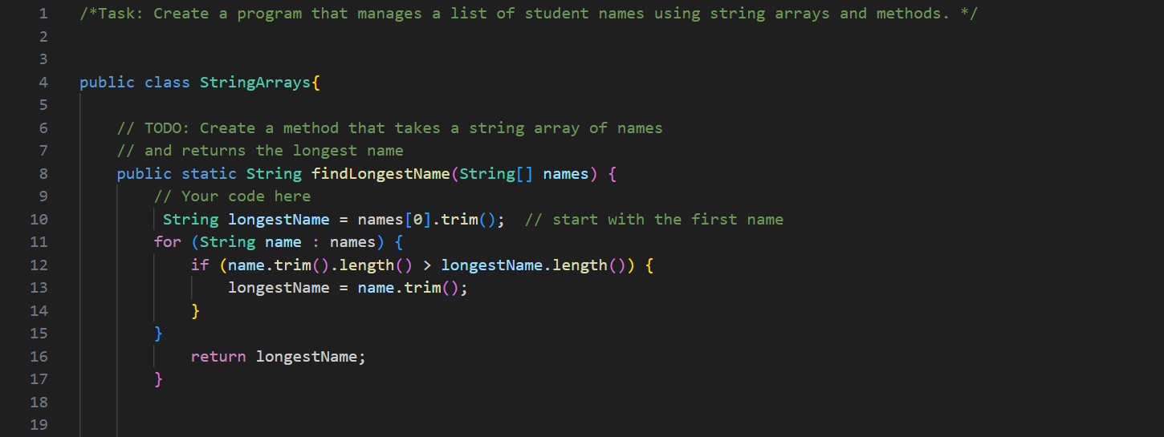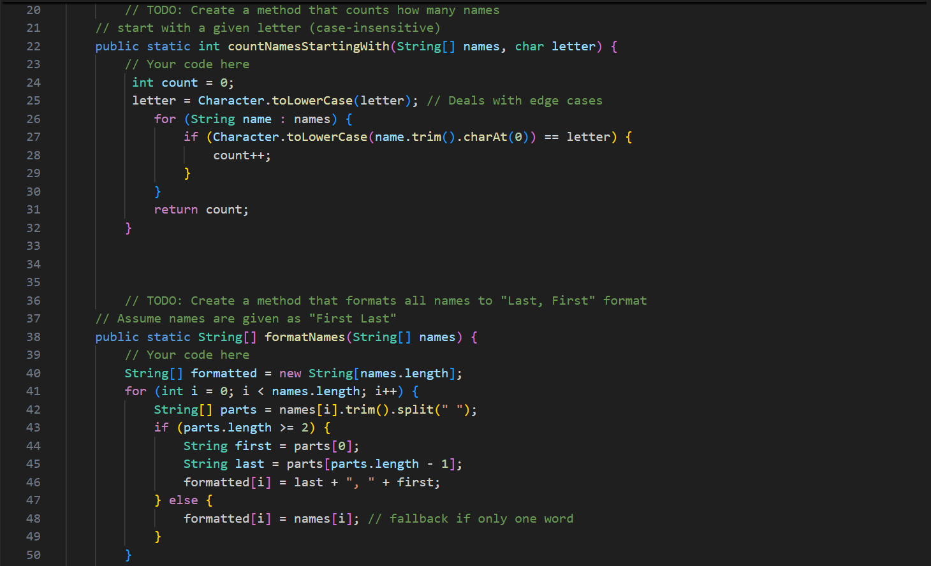

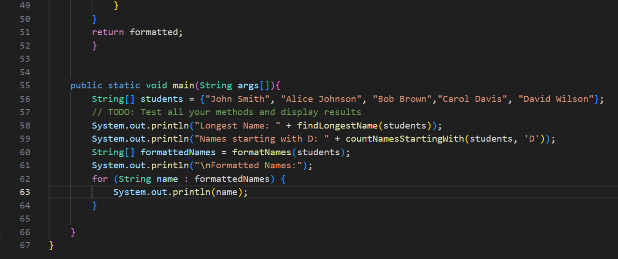

🛠 **PRACTICE PROBLEM 4:**

**Complete String Application (10 minutes)**

**Task**: Create a simple text processor that combines all concepts learned.

